7.3B – 2 (R.) three Z
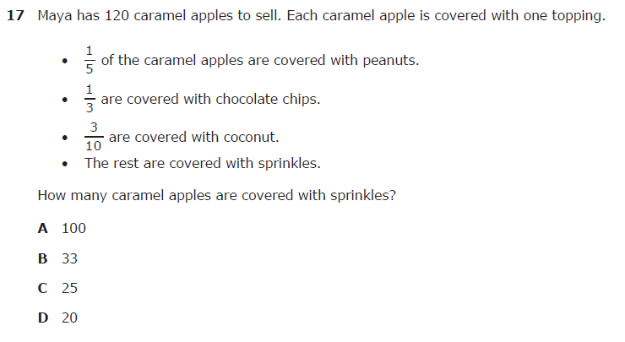

7.3B – 2 (R.) three 4.99
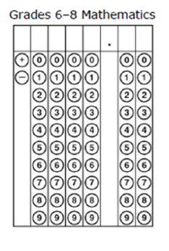
7.4A – 2 (R) four Z
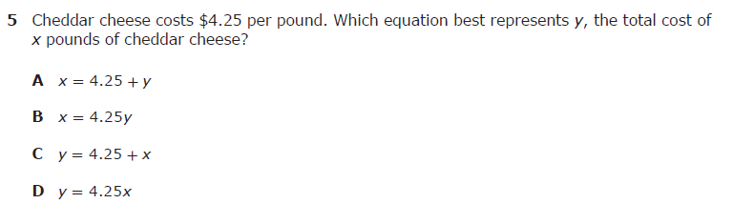

7.4A – 2 (R) five X
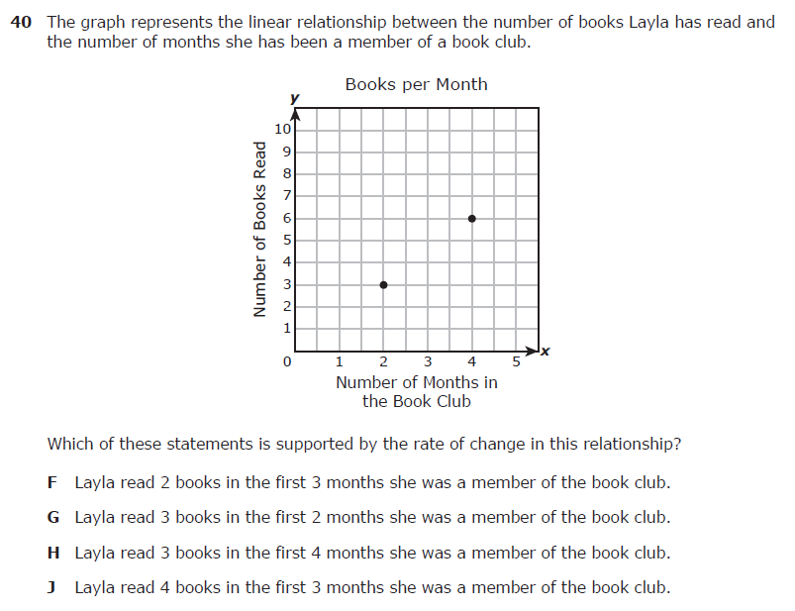
7.4D – 2 (R.) nine X

7.4D – 2 (R.) ten W
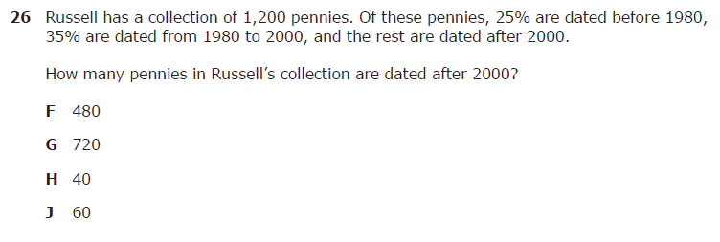

7.5C – 3 (R) nineteen Y
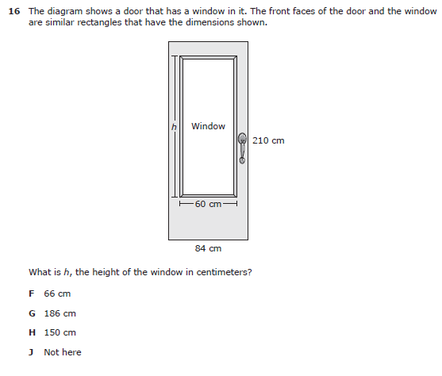
7.5C – 3 (R) twenty Y
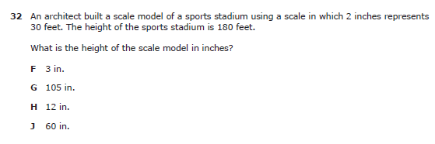

7.6G – 4 (R) sixteen W
7.6G – 4 (R) sixteen Z
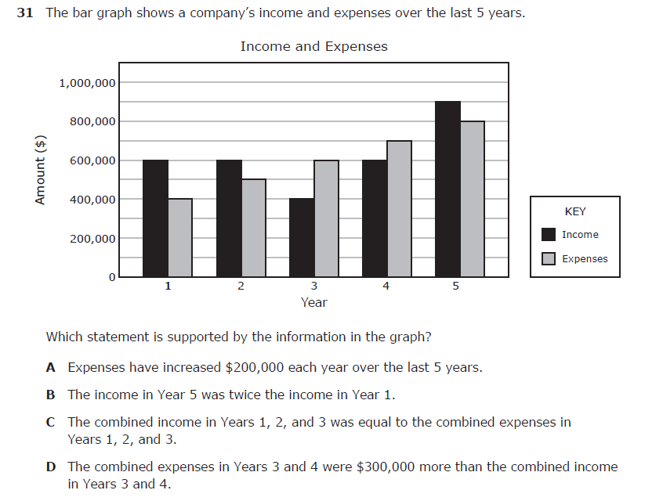
7.6H – 1 (R) twenty four Z
7.6H – 1 (R) twenty five Y

7.6I – 1 (R) sixteen Z

7.6I – 1 (R) seventeen W
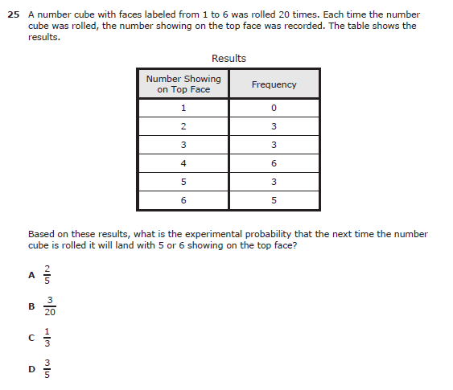
7.7A – 2 (R) twenty One Z
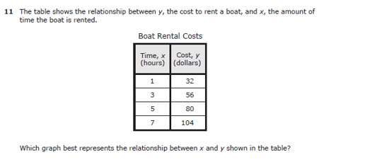
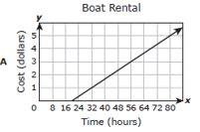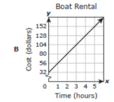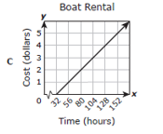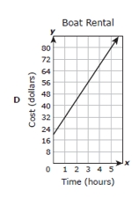
7.7A – 2 (R) twenty two Y
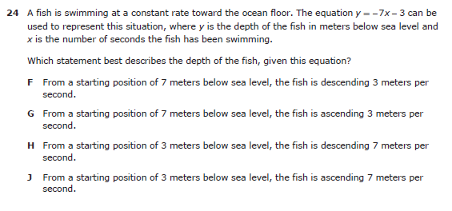

7.9A - 3 (R.) twenty four Y
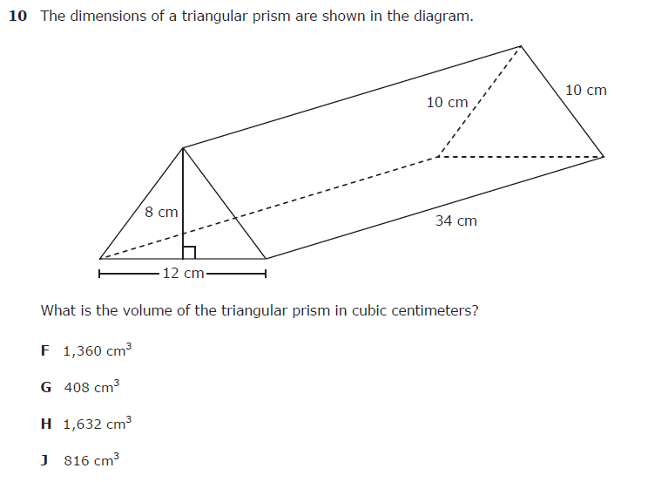
7.9A - 3 (R.) twenty four W
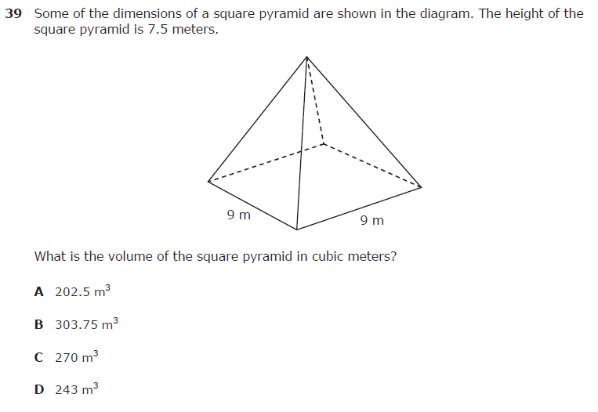
7.9B – 3 (R.) twenty six W
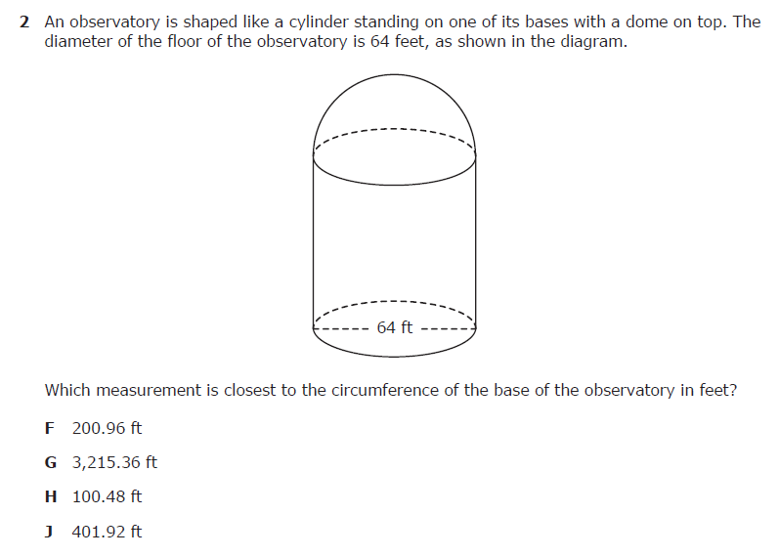
7.9B – 3 (R.) twenty seven Z
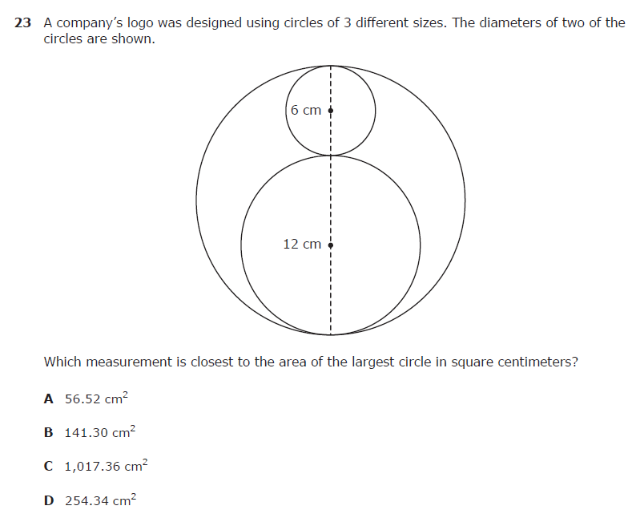
7.9C – 3 (R.) twenty nine X
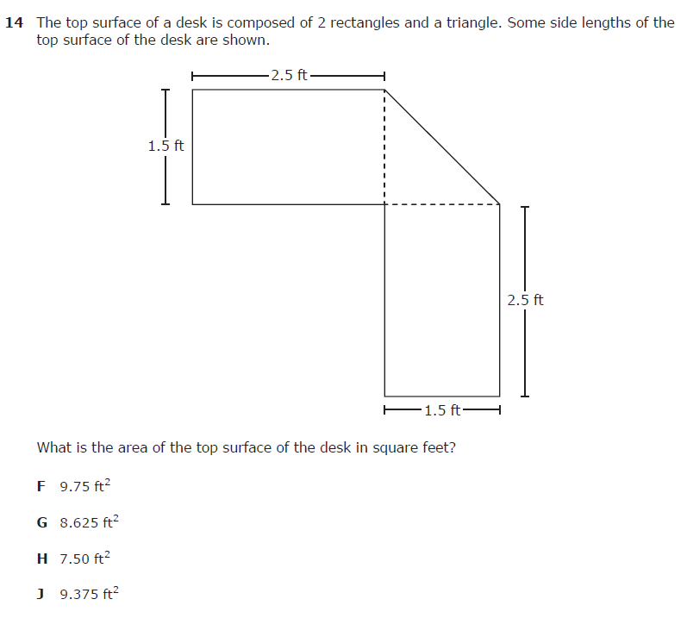
7.9C – 3 (R.) thirty Y
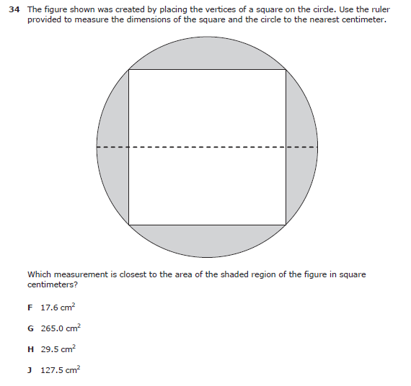
7.11A – 2 (R) thirty eight X
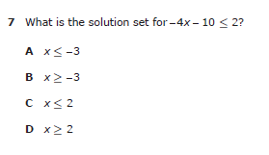

7.11A – 2 (R) thirty nine Z
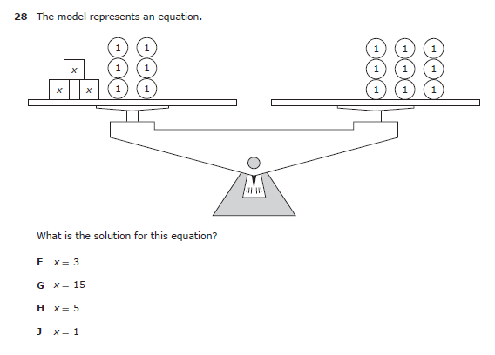
7.12A – 4 (R) thirty eight Y
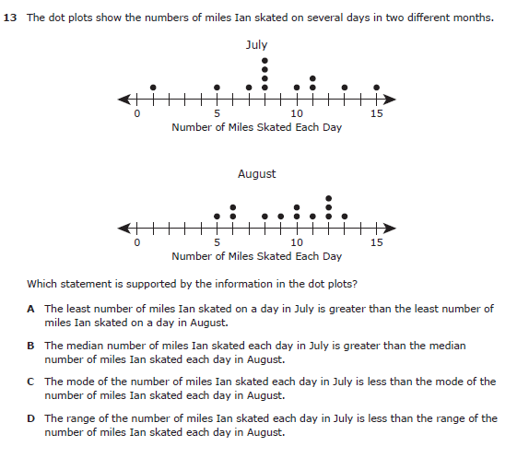
7.12A – 4 (R) thirty nine X
